1. This question is about the Rutherford model of the atom.
(a) Most alpha particles used to bombard a thin gold foil pass through the foil without a significant change in direction. A few alpha particles are deviated from their original direction through angles greater than 90°. Use these observations to describe the Rutherford atomic model.

......................................................................................................................................
......................................................................................................................................
......................................................................................................................................
......................................................................................................................................
......................................................................................................................................
......................................................................................................................................
......................................................................................................................................
......................................................................................................................................
......................................................................................................................................
......................................................................................................................................
(5)

(b) The isotope gold-197 () is stable but the isotope gold-199 () is not.
(i) Outline, in terms of the forces acting between nucleons, why, for large stable nuclei such as gold-197, the number of neutrons exceeds the number of protons.
...........................................................................................................................
...........................................................................................................................
...........................................................................................................................
...........................................................................................................................
...........................................................................................................................
...........................................................................................................................
(3)

(ii) A nucleus of decays to a nucleus of with the emission of an electron and another particle. State the name of this other particle.
...........................................................................................................................
...........................................................................................................................
(1)
(Total 9 marks)

2. This question is about decay of radium-226.
(a) A nucleus of the isotope radium-226 (Ra) undergoes α-decay with a half-life of
1.6 × 103 yr to form a nucleus of radon (Rn).
Define the terms isotope and half-life.
Isotope: ........................................................................................................................
......................................................................................................................................
Half-life: ......................................................................................................................
......................................................................................................................................
(2)

(b) Using the grid below, sketch a graph to show how the activity A of a sample of radium-226 (Ra) would be expected to vary with time t over a period of about 5.0 × 103 yr.
The activity of the sample at time t = 0 is A0.
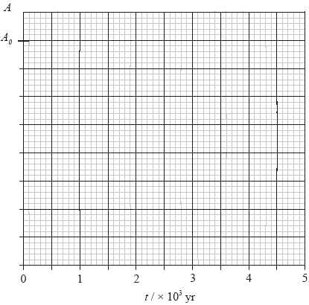
(3)

(c) The nuclear reaction equation for the decay of radium-226 (Ra) may be written as

(i) State the value of the proton number and neutron number of the isotope of radon (Rn).
Proton number: .................................................................................................
Neutron number: ...............................................................................................
(1)

(ii) Outline why the binding energy of Ra is less than that of Rn.
...........................................................................................................................
...........................................................................................................................
...........................................................................................................................
...........................................................................................................................
(2)

(d) The following data are available.
mass of Ra = 226.0254 u
mass of Rn = 222.0175 u
mass of α = 4.0026 u
Show that the energy released in the decay of a Ra nucleus is 4.94 MeV.
......................................................................................................................................
......................................................................................................................................
......................................................................................................................................
......................................................................................................................................
(2)
(Total 10 marks)

3. The number of neutrons and the number of protons in a nucleus of an atom of the isotope of uranium are

 | Neutrons | Protons
A. | 92 | 143
B. | 143 | 92
C. | 235 | 92
D. | 92 | 235
(Total 1 mark)

4. A sample contains an amount of radioactive material with a half-life of 3.5 days. After 2 weeks the fraction of the radioactive material remaining is
A. 94 %.
B. 25 %.
C. 6 %.
D. 0 %.
(Total 1 mark)

5. This question is about the spectrum of atomic hydrogen.
(a) The diagram represents the principal lines in the visible spectrum of atomic hydrogen.
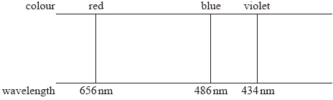
Outline how the spectrum can be produced and observed in the laboratory.

......................................................................................................................................
......................................................................................................................................
......................................................................................................................................
......................................................................................................................................
......................................................................................................................................
(3)

(b) Calculate the difference in energy in eV between the energy levels in the hydrogen atom that give rise to the red line in the spectrum.
......................................................................................................................................
......................................................................................................................................
......................................................................................................................................
......................................................................................................................................
(2)
(Total 5 marks)

6. This question is about radioactive decay.
(a) A nucleus of a radioactive isotope of gold (Au-189) emits a neutrino in the decay to a nucleus of an isotope of platinum (Pt).
In the nuclear reaction equation below, state the name of the particle X and identify the nucleon number A and proton number Z of the nucleus of the isotope of platinum.
X: ................................................................................................................................
A: ................................................................................................................................
Z: ................................................................................................................................
(2)

(b) The half-life of Au-189 is 8.84 minutes. A freshly prepared sample of the isotope has an activity of 124 Bq.
(i) Calculate the decay constant of Au-189.
...........................................................................................................................
...........................................................................................................................
(1)

(ii) Determine the activity of the sample after 12.0 min.
...........................................................................................................................
...........................................................................................................................
...........................................................................................................................
...........................................................................................................................
(2)
(Total 5 marks)

7. Which of the following is true about beta minus (β–) decay?
A. An antineutrino is absorbed.
B. The charge of the daughter nuclide is less than that of the parent nuclide.
C. An antineutrino is emitted.
D. The mass number of the daughter nuclide is less than that of the parent nuclide.
(Total 1 mark)

8. The graph below shows the number of nuclei N of a radioactive isotope as a function of time t.
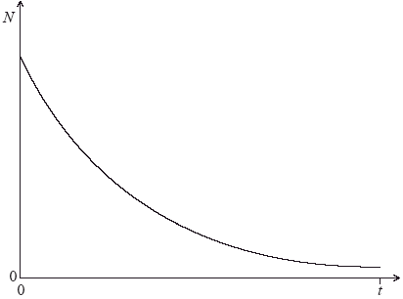
The slope of the curve at any given time is
A. independent of the decay constant.
B. proportional to the half-life of the isotope.
C. proportional to the number of radioactive nuclei remaining at that time.
D. proportional to the number of radioactive nuclei decayed.
(Total 1 mark)

9. A radioactive isotope has a half-life of two minutes. A sample contains sixteen grams of the isotope. How much time elapses until one gram of the isotope remains?
A. 6 minutes
B. 8 minutes
C. 10 minutes
D. 12 minutes
(Total 1 mark)

10. This question is about radioactive decay and binding energy.
(a) Describe what is meant by radioactive decay.
......................................................................................................................................
......................................................................................................................................
......................................................................................................................................
......................................................................................................................................
(2)

(b) A nucleus of potassium-40 (K-40) undergoes radioactive decay to a nucleus of argon-40 (Ar-40). In the reaction equation below, identify the proton number Z of argon and the particle x.
Z: .................................................................................................................................
x: .................................................................................................................................
(2)

(c) The mass of a K-40 nucleus is 37 216 MeV c–2. Determine the binding energy per nucleon of K-40.
......................................................................................................................................
......................................................................................................................................
......................................................................................................................................
......................................................................................................................................
......................................................................................................................................
......................................................................................................................................
......................................................................................................................................
(4)

(d) State why the binding energy of Ar-40 is greater than that of K-40.
......................................................................................................................................
......................................................................................................................................
(1)
(Total 9 marks)

11. Which of the following gives the correct number of protons and neutrons in a nucleus of carbon-14 ()?

 | Protons | Neutrons
A. | 8 | 6
B. | 6 | 8
C. | 14 | 6
D. | 6 | 14
(Total 1 mark)

12. The diagram shows some of the energy levels of a hypothetical atom.
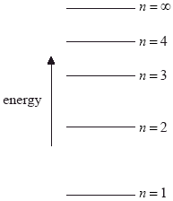
The atom is excited to the energy level n = 4. Which of the following transitions will produce a photon of the longest and the shortest wavelength?

 | Longest wavelength | Shortest wavelength
A. | 4 → 3 | 4 → 1
B. | 4 → 1 | 4 → 3
C. | 2 → 1 | 4 → 3
D. | 4 → 3 | 2 → 1
(Total 1 mark)

13. This question is about radioactive decay.
(a) The alpha particles produced in alpha decay have discrete energies. Suggest how this observation provides evidence for the existence of nuclear energy levels.
......................................................................................................................................
......................................................................................................................................
......................................................................................................................................
......................................................................................................................................
(2)
(b) A nucleus of the isotope fluorine-18 decays into a nucleus of oxygen-18 by the emission of a positron and neutrino. Outline how the nature of the β-decay energy spectrum of fluorine-18 suggests the existence of the neutrino involved in the decay.
......................................................................................................................................
......................................................................................................................................
......................................................................................................................................
......................................................................................................................................
......................................................................................................................................
(3)

(c) A freshly prepared sample of fluorine-18 has an activity of 1.12 MBq. Its activity four hours later is 0.246 MBq.
(i) Show that the decay constant for fluorine-18 is 0.379 hr–1.
...........................................................................................................................
...........................................................................................................................
...........................................................................................................................
...........................................................................................................................
...........................................................................................................................
(3)

(ii) Calculate the half-life of fluorine-18.
...........................................................................................................................
...........................................................................................................................
(1)

(d) The energy of a beta particle in the decay of the sample in (c) is 8.4 × 10–15 J. Show that the de Broglie wavelength of this particle is 5.3 × 10–12 m.
......................................................................................................................................
......................................................................................................................................
......................................................................................................................................
......................................................................................................................................
(2)
(Total 11 marks)

14. This question is about radioactive decay.
(a) The decay constant for a particular isotope is λ = 0.048 s–1. A sample of the isotope initially contains 2.0 × 1012 nuclei of this isotope.
(i) Define decay constant.
...........................................................................................................................
...........................................................................................................................
(1)

(ii) Estimate the number of nuclei that will decay in the first second.
...........................................................................................................................
...........................................................................................................................
(1)

(b) The graph shows the variation with time t of the activity A of a sample containing radioactive material that consists of two different isotopes. Each isotope decays into a stable daughter isotope.
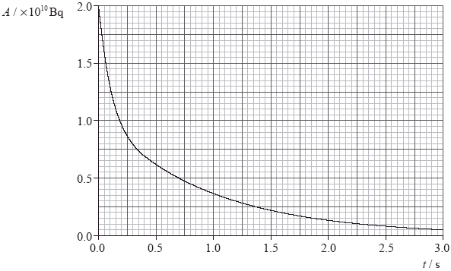

(i) Use the graph to explain how it may be deduced that the sample contains more than one isotope.
...........................................................................................................................
...........................................................................................................................
...........................................................................................................................
...........................................................................................................................
(2)

(ii) One of the isotopes in the sample has a half-life that is shorter than 0.20 s. Use the graph to estimate the half-life of the other isotope. Explain your working.
...........................................................................................................................
...........................................................................................................................
...........................................................................................................................
...........................................................................................................................
(2)
(Total 6 marks)

15. This question is about the hydrogen atom.
(a) A parallel beam of visible light is shone through monatomic hydrogen gas.
The radiation emerging from the gas is analysed by comparing the incident and emerging intensities at various wavelengths. It is found that at a wavelength of 490 nm the intensity of the emergent beam is greatly reduced.
The diagram shows some of the electron energy states of the hydrogen atom where n is the quantum number of the energy level.
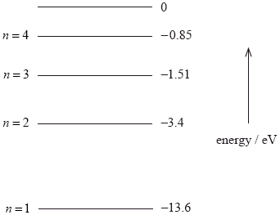

(i) Calculate the energy, in eV, of a photon of light of wavelength 490 nm.
...........................................................................................................................
...........................................................................................................................
...........................................................................................................................
...........................................................................................................................
(2)

(ii) Use your answer in (a)(i) and the energy level diagram to explain the reduction in intensity of the emergent beam.
...........................................................................................................................
...........................................................................................................................
...........................................................................................................................
...........................................................................................................................
...........................................................................................................................
...........................................................................................................................
...........................................................................................................................
...........................................................................................................................
...........................................................................................................................
...........................................................................................................................
(4)

(b) Outline how the Schrödinger model of the hydrogen atom leads to the idea of discrete electron energy states.
......................................................................................................................................
......................................................................................................................................
......................................................................................................................................
......................................................................................................................................
......................................................................................................................................
......................................................................................................................................
......................................................................................................................................
......................................................................................................................................
(4)
(Total 10 marks)

16. A nucleus of the isotope potassium-40 decays to a nucleus of the isotope argon-40. The reaction equation for this decay may be written as
Which of the following correctly identifies the proton number of argon-40 and the particle X?

 | Z | X
A. | 18 | β–
B. | 18 | β+
C. | 19 | β+
D. | 19 | β–
(Total 1 mark)

17. Which of the following decay sequences would result in the daughter nucleus having the same proton number as the parent nucleus?
A. Alpha followed by gamma
B. Beta (β– ) followed by gamma
C. Alpha followed by beta (β–) followed by beta (β–)
D. Beta (β–) followed by gamma followed by gamma
(Total 1 mark)

18. Emission and absorption spectra provide evidence for
A. the nuclear model of the atom.
B. natural radioactivity.
C. the existence of isotopes.
D. the existence of atomic energy levels.
(Total 1 mark)

19. Two samples of radioactive substances X and Y have the same initial activity. The half-life of X is T and the half-life of Y is 3T. After a time of 3T the ratio
is
A. 8.
B. 4.
C. .
D. .
(Total 1 mark)

20. A radioactive substance S has a decay constant λS, substance T has a decay constant λT. Initially, a sample of S contains NS nuclei and a sample of T contains NT nuclei. The initial activity of both samples is the same.
The ratio is
A. 1
B.
C.
D. λSλT
(Total 1 mark)

21. This question is about radioactive decay.
Nitrogen-13 () is an isotope that is used in medical diagnosis. The decay constant of nitrogen-13 is 1.2 × 10–3 s–1.
(a) (i) Define decay constant.
...........................................................................................................................
...........................................................................................................................
...........................................................................................................................
(1)

(ii) A sample of nitrogen-13 has an initial activity of 800 Bq. The sample cannot be used for diagnostic purposes if its activity becomes less than 150 Bq. Determine the time it takes for the activity of the sample to fall to 150 Bq.
...........................................................................................................................
...........................................................................................................................
...........................................................................................................................
...........................................................................................................................
(2)

(b) (i) Calculate the half-life of nitrogen-13
...........................................................................................................................
...........................................................................................................................
...........................................................................................................................
(1)

(ii) Outline how the half-life of a sample of nitrogen-13 can be measured in a laboratory.

...........................................................................................................................
...........................................................................................................................
...........................................................................................................................
...........................................................................................................................
...........................................................................................................................
(3)

(c) Nitrogen-13 undergoes β+ decay. Outline the experimental evidence that suggests another particle, the neutrino, is also emitted in the decay.
......................................................................................................................................
......................................................................................................................................
......................................................................................................................................
......................................................................................................................................
......................................................................................................................................
(2)
(Total 9 marks)

22. Two samples of radioactive substances X and Y have the same initial activity. The half-life of X is T and the half-life of Y is 3T. After a time of 3T the ratio
is
A. 8.
B. 4.
C. .
D. .
(Total 1 mark)

23. The nuclear equation below is an example of the transmutation of mercury into gold.
+ X
The particle X is a
A. gamma-ray photon.
B. helium nucleus.
C. proton.
D. neutron.
(Total 1 mark)

24. The diagram below shows some of the energy levels available to an electron in a caesium atom.
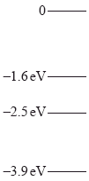
Photons of energy 0.9 eV pass through a sample of low pressure caesium vapour. Which of the following gives the energy transition of the electron when a photon is absorbed?
A. From –3.9 eV to 0
B. From –2.5 eV to –1.6 eV
C. From –1.6 eV to –2.5 eV
D. From 0 to –3.9 eV
(Total 1 mark)

25. Which nucleons in a nucleus are involved in the Coulomb interaction and the strong short-range nuclear interaction?

 | Coulomb interaction | Strong short-range interaction
A. | protons | protons, neutrons
B. | protons | neutrons
C. | protons | protons
D. | protons, neutrons | neutrons
(Total 1 mark)

26. The half-life of a radioactive isotope is 10 days. What is the percentage of the sample remaining after 25 days?
A. 0 %
B. 18 %
C. 25 %
D. 40 %
(Total 1 mark)

27. Which of the following energy level diagrams best represents the kinetic energy EK of the “electron in a box” model, where an electron is confined to move in one dimension? The variable n is an integer (1, 2, 3, 4 etc.).
A.
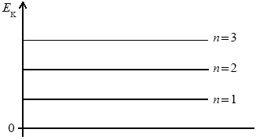

B.
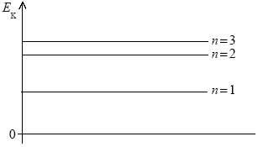

C.
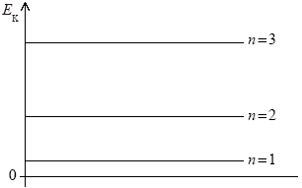

D.
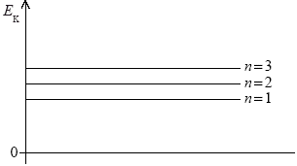
(Total 1 mark)

28. This question is about radioactive decay.
Iodine-124 (I-124) is an unstable radioisotope with proton number 53. It undergoes beta plus decay to form an isotope of tellurium (Te).
(a) State the reaction for the decay of the I-124 nuclide.
......................................................................................................................................
(2)

(b) The graph below shows how the activity of a sample of iodine-124 changes with time.
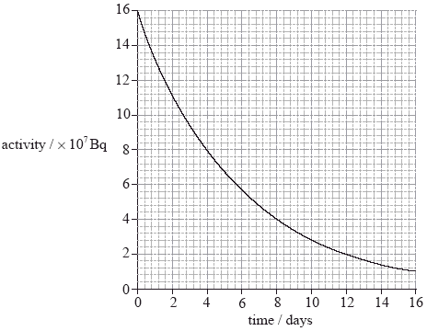

(i) State the half-life of iodine-124
...........................................................................................................................
(1)

(ii) Calculate the activity of the sample at 21 days.
...........................................................................................................................
...........................................................................................................................
...........................................................................................................................
...........................................................................................................................
...........................................................................................................................
...........................................................................................................................
(3)

(iii) A sample of an unknown radioisotope has a half-life twice that of iodine-124 and the same initial activity as the sample of iodine-124. On the axes opposite, draw a graph to show how the activity of the sample would change with time.
Label this graph X.
(1)

(iv) A second sample of iodine-124 has half the initial activity as the original sample of iodine-124. On the axes opposite, draw a graph to show how the activity of this sample would change with time. Label this graph Y.
(1)
(Total 8 marks)

29. Different nuclides spontaneously undergo radioactive decay, emitting either α, β or γ radiation.
Which of the following correctly identifies all the emissions that do not have discrete energies?
A. α
B. β
C. γ
D. α and γ
(Total 1 mark)

30. Which of the following causes the greatest number of ionizations as it passes through 1 cm of air?
(The total energy of the ionizing radiation is the same.)
A. An alpha particle
B. A beta particle
C. A gamma-ray
D. An X-ray
(Total 1 mark)

31. This question is about atomic spectra.
Diagram 1 shows some of the energy levels of the hydrogen atom. Diagram 2 is a representation of part of the emission spectrum of atomic hydrogen. The lines shown represent transitions involving the –3.40 eV level.
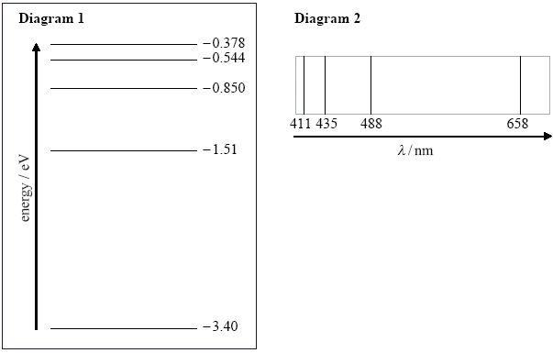

(a) Deduce that the energy of a photon of wavelength 658 nm is 1.89 eV.
......................................................................................................................................
......................................................................................................................................
......................................................................................................................................
......................................................................................................................................
......................................................................................................................................
......................................................................................................................................
(3)

(b) (i) On diagram 1, draw an arrow to show the electron transition between energy levels that gives rise to the emission of a photon of wavelength 658 nm. Label this arrow with the letter A.
(1)

(ii) On diagram 1, draw arrows to show the electron transitions between energy levels that give rise to the emission of photons of wavelengths 488 nm, 435 nm and 411 nm.
Label these arrows with the letters B, C and D.
(1)

(c) Explain why the lines in the emission spectrum of atomic hydrogen, shown in diagram 2, become closer together as the wavelength of the emitted photons decreases.
......................................................................................................................................
......................................................................................................................................
......................................................................................................................................
......................................................................................................................................
......................................................................................................................................
......................................................................................................................................
(3)
(Total 8 marks)

32. A freshly prepared sample contains 4.0 μg of iodine-131. After 24 days, 0.5 μg of iodine-131 remain. The best estimate of the half-life of iodine-131 is
A. 8 days.
B. 12 days.
C. 24 days.
D. 72 days.
(Total 1 mark)

